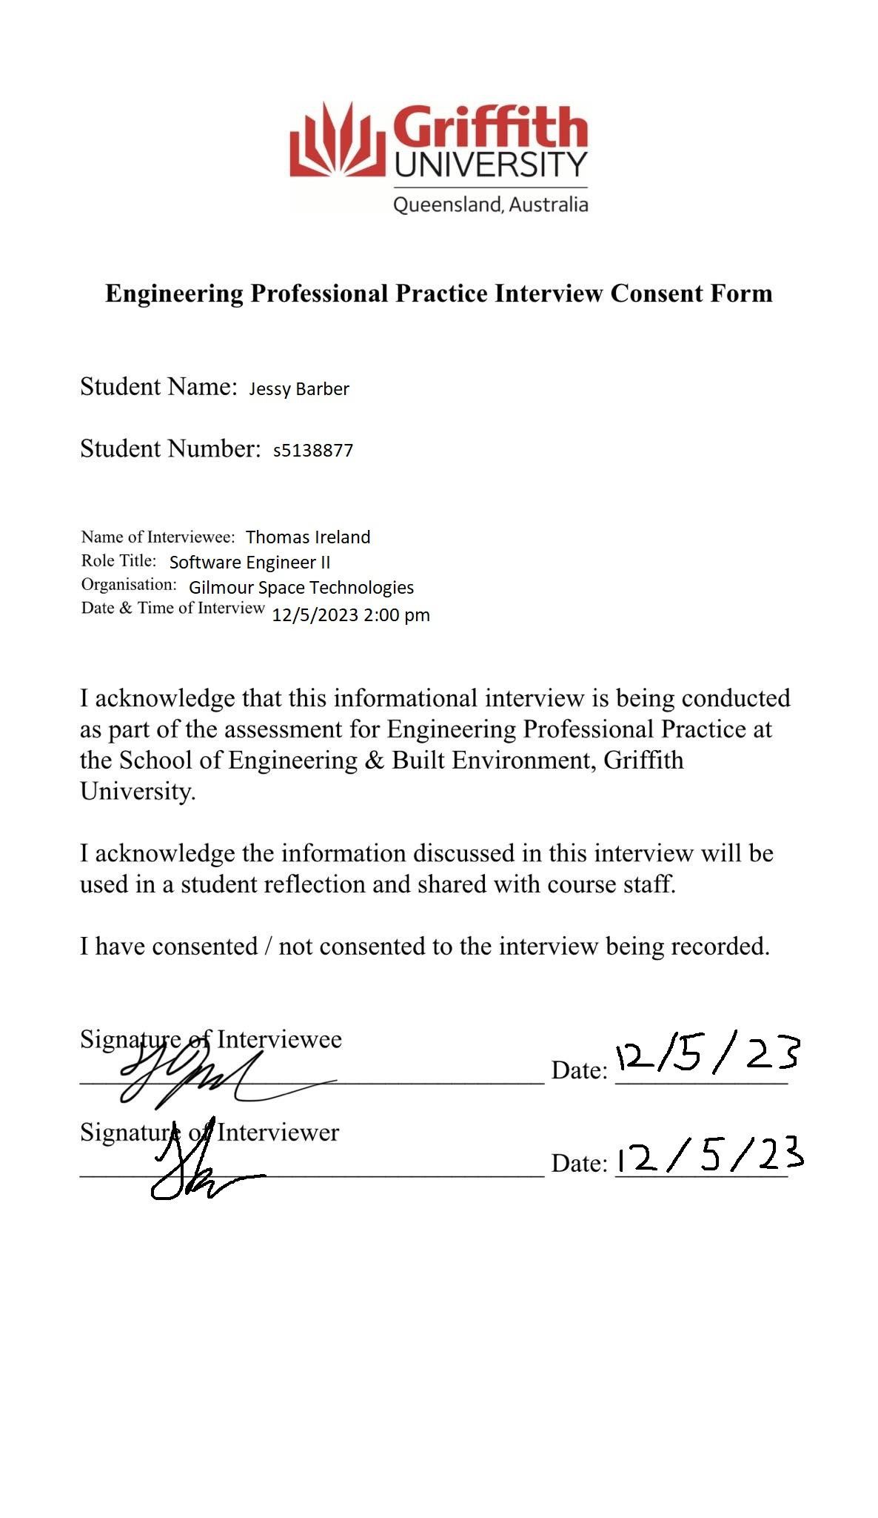

# Choice of Interviewee

Thomas Ireland graduated from Griffith University with a degree in Electrical & Electronics Engineering in 2019 and is now a well-regarded Software Engineer II at Gilmour Space Technologies. Thomas was the ideal fit for this interview as his university experiences and career development align very closely with my own experiences and career ambitions. The interview was exceedingly insightful as my own goal is to become a graduate avionics engineer in the aerospace industry. Avionics and software engineering at Gilmour Space Technologies are very closely related fields and therefore the insight I have gained from understanding Thomas’ professional experience is invaluable to my growth as a future engineer. Thomas’ role is a dynamically changing one, and in the interview, he explains how technical, interpersonal and safety critical concepts are embedded within the engineering profession.

# Pathway from university to professional practice

Mr. Ireland described his time at university and explained how Griffith prepared him for his professional career. Thomas explained that university is the perfect place to learn the engineering fundamentals, focusing on the first-year courses as being a great introduction to interdisciplinary experience. He explained that often the immediate stakeholders of a company are likely to be internal, and so learning collaboration via interdisciplinary skills and understanding is vital. Thomas highlighted that achieving a base level of understanding across multiple fields facilitates effective communication and understanding the needs and requirements for a complex design task. He reiterated that learning these skills during group projects at university was invaluable and learning interpersonal skills such as leveraging personality types and understanding member’s strengths is equally important to technical proficiency. “You can put a bunch of smart people in a room, but if you don’t know how to position everyone so they can all play to their strengths, the group’s effectiveness will be severely limited”. Thomas found the transition from university to professional practice easy thanks to Griffith’s WIL program. He mentions that his internship was with Gilmour which made the full-time transition there supportive and less stressful. Thomas focused on the idea that the transition to professional practice was especially engaging, “I felt I could focus 100% on my professional work as I no longer had to worry about the completion of my uni degree”.

I could relate to Thomas’ experience in his first year at Griffith as I enjoyed taking classes that were not directly related to my major. These effectively acted as a primer and a foundation for engineering and scientific thinking. It was very interesting to hear his perspective on leveraging group dynamics and how these sorts of interpersonal skills were just as important as technical proficiency. It was also reassuring to hear how much the WIL IAP program helped to set up Thomas for his career, which is something that I am currently undertaking.

Like Thomas, I completed a twelve-week internship at Gilmour Space Technologies which proved to be one of the most insightful and enjoyable experiences of my life. It was great to hear how much the internship helped Thomas progress from university to professional practice and puts into perspective what I can expect of myself. I will focus on honing my interpersonal skills and really make the most of the last group projects that I have. I now have a better expectation of what to expect when communicating with stakeholders in a company, and I am determined to continue to focus on gaining a broad foundation of knowledge and developing interdisciplinary understandings and skills.

# Professional practice

Thomas detailed the workload and complexity to expect in the aerospace industry. He mentioned that Gilmour eased him into responsibilities, and that with the more experience he gained the more complex and critical the projects became. “Within 6-12 months I was given my own projects and within the first couple of years I became the Subject Matter Expert (SME) on the embedded flight software”. Thomas explained that working with others in the team helped him learn that everyone is still constantly learning, and that passion and determination is more important than inherent skill. He talked about the career progression inside the company, and how Gilmour focuses on the idea that progression is based on merit. “Show to the company with tangible results that you are worthy of promotion and advancement”. Gilmour has introduced a new quarterly KPI system which involves setting ambitious goals and consistently achieving them by the end of the quarter. Thomas explained that performance reviews are done every six months and that remuneration and position is evaluated on the behalf of these KPIs and this idea of merit.

Learning about Gilmour’s stance on career progression was incredibly insightful and gives me an idea of how performance is assessed and evaluated in a professional context. Thomas mentioned the concept of SME a few times in the interview, which compliments his point about consistent learning. To me, this means that at Gilmour there are opportunities to become an invaluable asset of the team through dedication and hard work.

These points were very helpful for me to gain insight into how progressive learning is dealt with in a professional context. I love the idea of further developing my skills in industry, and the idea of becoming an SME in a subject is something that greatly appeals to me. The points that Thomas covered appeal to me greatly, particularly the idea of having a general foundation of knowledge but also grasping the opportunity of becoming especially skilled and knowledgeable in specific areas. In my career I want this ability to both have generalist interdisciplinary skills but also rich and deep specialist understanding in more specific areas. I’ve learnt that this is at the core of an engineering team dynamic, where everyone shares that general foundation of knowledge, but everyone can bring to the table their own specialist perspectives.

# Industry challenges and job satisfaction

Thomas explained some of the biggest challenges that are involved in working at an aerospace company. This is especially the case at Gilmour due to the development of safety-critical flight software where there is an exceptionally high level of quality required. Thomas explained that the way to overcome this is to realize that there are other employees at the company that have decades of experience in the aerospace sector and to leverage their knowledge and develop mentor relationships. He explained that since the company is currently a startup landscape, it is important to be flexible in writing software since requirements are bound to change and re-work is required. He mentioned that sometimes products/projects that get worked on for months can get scrapped and that this is inevitable due to the nature of the industry and the company’s priorities. “I believe that if you can’t deal with this, the startup environment is not for you”. Thomas explained that software in the aerospace industry requires a higher standard of safety, reliability and testing which is something that is not evident in many other industries. “Because of this, I believe it is the perfect place to learn fundamental skills and habits. I’ve since learnt software for other industries and have found it to be very easy to due to my previous learning”. Thomas mentioned that he is ambitious when it comes to challenging projects, often giving himself an aggressive schedule to challenge himself and grow.

The intensity of software standards in the aerospace industry was something that I subconsciously understood, but it was another thing entirely to hear Thomas talk about it. It puts into perspective just how rigorous the systems in a rocket are, and how critical these systems are to the success of a launch. Developing mentor relationships and leveraging the decades of aerospace experience from members of the team is something that seems to be the absolute key to success in this industry. I had personal experience with this during my internship at Gilmour, even with Thomas himself. I asked many questions and sought help from various engineers which assisted me in tackling my own challenging projects.

Thomas’ explanation of the kick starter environment is something that appeals to me. I also tend to work by aggressive schedules, and I like to challenge myself with a large workload. It was reassuring to hear that this is commonplace and a result of the passion and dedication of each of the team members. This fast past approach to projects is something that I will not forget and is something that I need to improve on since I can sometimes get attached to projects I am working on. Listening to Thomas’ advice, I need to find a balance between dedication and moving on. Working hard on a project with an aggressive schedule but also being comfortable with letting a project go if it no longer aligns with the team’s priorities is what will help me excel in the industry.

# Most important skills

I asked Thomas about the most important skills in the workplace, “Technical skills are obviously very important, but the most undervalued skills are interpersonal and communication”. Thomas outlined the idea of learning to sell your work, and how to work effectively within a team. “I see so many super intelligent people with strong technical skills limit themselves because they lack interpersonal skills”. Thomas explained that to develop technical skills, the best thing to do is to work on coding projects outside of work. He mentioned that learning different languages and working on projects that I wouldn’t normally work on are essential. “You would be surprised at how much it can help your critical thinking and apply a different way of thinking to your main work”. Thomas made clear that reading books, watching YouTube videos, and going out and meeting new people and making new friends are great ways to improve technical, communication and interpersonal skills. He articulated the fact that a range of personality types perform well within the industry, and how these personalities can better suit different developer roles. These roles range from UI/UX front-end design, low-level development and architecture system design. Thomas mentioned that it is preferred for graduate students to demonstrate some talent through their own projects that relate to the role looking to be filled, but companies mostly look for passion, enthusiasm, work ethic and cultural fit. “Technical skills can always be learnt, if you have passion and work ethic. Regardless of how brilliant you may be, if you aren’t a cultural fit, then you may not enjoy working with the team and may not feel like it is the right place for you”. Thomas finished by explaining that people work best when they enjoy what they do and feel like they are making a difference.

It became very clear that at Gilmour there is an equal emphasis on technical and interpersonal skills. These are what shine through when working on personal and team projects, and the way to develop these skills is by working on my own personal projects and becoming more sociable. It is evident that having these interpersonal skills are what allow for opportunities to arise, and the technical skills are what bring those opportunities into reality. I had first-hand experience with Gilmour’s selection process during my internship interview. Even though I don’t have the best GPA, I have a passion for electronics and heaps of personal projects to show the team members. After spending my time at the company, I can understand how important the cultural fit is since it allowed me to develop good relationships with my co-workers.

It was insightful to hear Thomas talk about how different personality types fit different developer roles. I am aspiring to become an Avionics engineer which involves a lot of low-level embedded system software, and hearing that this requires a high level of analytical skill and attention to detail gives me even more motivation to hone those skills. I’ve taken so much on-board from what Thomas has said and I have started working on more personal projects and my communication skills. Thanks to Thomas, I have lost the anxiety on working on projects that are not directly related to my role. The freedom to work on any personal projects that seem interesting with the perspective that I can develop my critical thinking skills has accelerated my engineering and programming development. This is something that I want to further develop and bring forward with me into my future career.

# Leadership and teamwork

Asking Thomas about teamwork in the company, he explained that collaboration is essential. Gilmour has regular team meetings, and they use many project management tools to coordinate tasks. Thomas elaborated on the idea of interpersonal skills in the context of teamwork, “A key skill is being able to communicate a complex idea to people that may have very little understanding of it”. This is the case due to the diverseness of engineers at Gilmour and why it is such an important skill to learn when collaborating in a team. I asked Thomas about his leadership roles at Gilmour, and he explained that he is involved in mentoring junior engineers and coordinating team efforts on some of his projects that he is the SME for. Thomas described the process of regular software reviews for any component of work that anyone in a team completes and highlighted that this is a great opportunity for coaching and mentoring. Thomas revealed the support from his own mentors, “I often seek guidance from some engineers in the team who have had decades of experience doing what I am currently doing. Even if the experience is not directly relevant, the way of thinking about the problem can be immensely helpful”.

It was refreshing to hear the openness of the team members at Gilmour, and how supportive and nourishing the workplace is. During my time at Gilmour, I was directly involved in these team meetings and Sprint based planning techniques. They are fast-paced and light-hearted whilst being informative and productive. Thomas was one of my mentors during my internship, and he gave me the confidence to ask questions and explore new ideas. I was also able to observe Thomas seek guidance in the workplace first-hand and overhear many interdisciplinary technical discussions.

The perspective of seeking guidance even though it might not be directly applicable is something that I have learnt from this interview and plan to incorporate in my career. This interview with Thomas and my internship has taught me to not be ashamed to ask questions and to always seek knowledge from my co-workers. I have realized that this is why those interpersonal skills are so important because you must get to know your fellow team members and their professional backgrounds. In order to seek out SMEs you must understand who is the SME which can often come up in casual conversation. Thomas’ perspective on teamwork and leadership is inspiring, and it is a perspective that I plan to carry through into my career.

# Future of the aerospace industry and a career retrospective

I asked Thomas about the future of the aerospace industry, and he discussed that the sector would see significant expansion over the next decade. This expansion comes with increased funding in sovereign launch capability, space exploration and satellite technology. “Gaining skills early will be huge for future career prospects within the country. This will likely boost the Australian economy by creating jobs and inspiring innovation”. Thomas outlined that Gilmour plans to continue developing cutting-edge technology and mentioned the possibility of exploring manned space missions. After discussing the future of the industry, I asked Thomas what he would change if he could go back to my position, “If I could go back, I would take more advantage of networking opportunities. Building a strong professional network can be immensely beneficial”. He gave me the advice to maintain a balance between focusing on my studies and gaining practical experience through internships or projects. Thomas explained that this kind of experience may have to involve some sacrifice in my last courses at university but that it would pay dividends after I graduate. When discussing Thomas’ schedule, he advised, “Know when you to need to surge and spend extra hours, and when you need to focus on your personal life. You can’t give it your all if you end up burning out. However, there will be times when you may need to sacrifice some days to ensure that you can deliver on ambitious goals”.

It is so exciting to hear about the future growth of the aerospace industry in Australia and it is something that I strive to be a part of. The prospect of gaining these skills early is also something that really appeals to me and allows me to reassure myself that I am on the correct path. It was very beneficial to learn what Thomas would change if he was back in my shoes, putting into perspective how important networking and making connections is. After completing my internship, I can see firsthand how important professional experience is. I indeed had to sacrifice some assessment items in favor of practical experience, but I can already see how beneficial this decision was and Thomas helped to remind me of this.

I plan to take Thomas’s advice and take part in the last networking opportunities at Griffith before I graduate. I also plan to have better time management skills and understand how to strike that balance between work and personal life. Understanding this balance is important to avoid burn-out and will be an important skill for me to learn so that I can hit ambitious goals in my career.